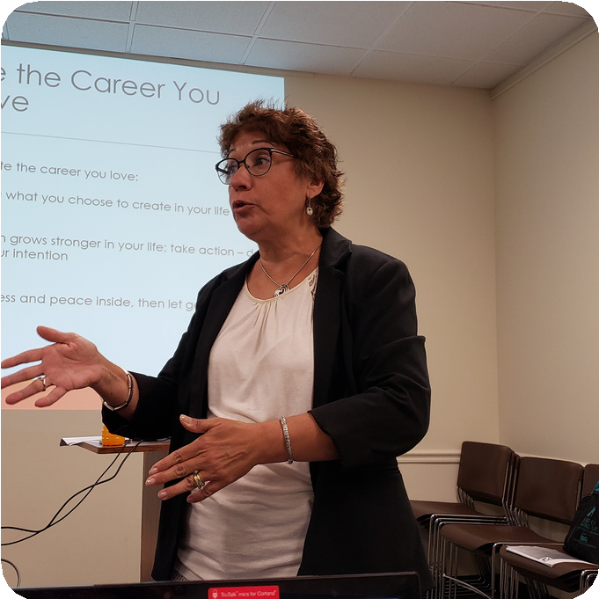
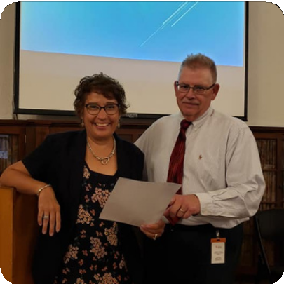

From Job to Joy

Tina Kadish
Author | Speaker | Event Host | Workshop Facilitator
International speaker, up-and-coming author, and business coach for women who are ready to leave the corporate world, Tina Kadish founded
From Job To Joy, to help unfulfilled women transition out of the corporate world and into entrepreneurship with her signature
F.R.E.E.D.O.M Formula- 7 Steps to uplevel your life.

Tina Kadish is a truly inspirational speaker. Her speaking is so powerful and positive and I admire her for reinventing her life and leave a secure position to do so. I think she had techniques and message that most resonated with me of all the similar speakers I have seen. What a great role model for all the women in the group as we all deal with things that can derail us.

Taking Corporate women through the process of becoming fulfilled entrepreneurs

tkadishcoach@gmail.com @fromjobtojoy www.fromjobtojoy.com

From Job to Joy

Author | Speaker | Event Host | Workshop Facilitator

Ms. Kadish’s presentation was impactful and
organized. I enjoyed how she stared that it was a 6- year journey to actually leave her job. She embraced her vision and applied her SMART steps. She engaged with the group well and I certainly recommend her an
additional invite. Ms. Kadish is a very charismatic speaker. “I’m never tired of listening to her.
Signature Talks

The Goal
To Teach Women it's OK to Leave Their Corporate Job and Do Something They Love

“I attended Tina Kadish’s “Master your Mindset to Career Success” training. This training was an excellent class to begin changing my mindset towards a career transition. Tina is a compassionate teacher using her own professional experiences to demonstrate her expertise in career transition and entrepreneurship. This was an interactive workshop, which allowed me to learn and engage with Tina and others that were attending the training. I recommend the training to those in career transition or

Goal Setting & Vision Mapping

Participants will explore the power of setting goals and visualization so that they can achieve
success in their life. They will also learn how setting S.M.A.R.T. goals is critical for their life. Participants will have a clear action plan to begin creating their goals.

Create a Growth Mindset for Success
Learn the power of having a Growth Mindset for success in life and business. Participants will learn the two types of mindsets and how they impact you in life and business. A 4-step process to reprogram your mindset will be shared and how this process can be applied in your life or business.

How to Discover Your Life Purpose
Participants will learn the power of identifying their purpose in their life and how it impacts l success. They will also learn how limiting beliefs get in the way of living your purpose.
Participants will uncover the 3-step formula to discover their purpose and the secret to success when it’s aligned with their purpose.

looking to reinvent yourself”. Incubate Freedom in Uncertain Times
Signature talk and workshop walking audience through the 7 steps to thrive in life and business. Participants walk away with a personalized step- by-step action manual helping them achieve their ultimate goals.

tkadishcoach@gmail.com @fromjobtojoy www.fromjobtojoy.com

From Job to Joy
Author | Speaker | Event Host | Workshop Facilitator

To Teach Women it's OK to Leave Their Corporate Job and Do Something They Love

I've heard people talk about knowing your 'why' dozens of times, but I was never really able to understand mine until taking this workshop.

Workshop
Success Incubator
7 Steps to thrive in life and business

Participants will learn the proven 7 step method to thrive in life and business so that they can be successful. They will also learn how to look at challenges that come with growth, overcome limiting beliefs that block their growth. By the time they have completed this 7-step process, participants will have created easy-to-implement micro shifts that dramatically improve their life and business:

- Faith – Belief in a higher power is foundational
- Release – Learn to let go of the outcome
- Evaluation – Step back to view the bigger picture
- Energy – Attention follows intention
- Determination – Passion brings you through any obstacle
- Optimism – Utilize strategies for weathering the ups and downs of business (and life)
- Mindset – A healthy and sound mindset is everything

tkadishcoach@gmail.com @fromjobtojoy www.fromjobtojoy.com

